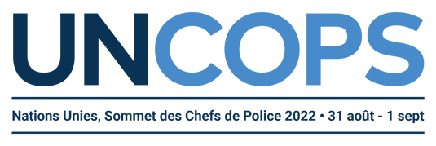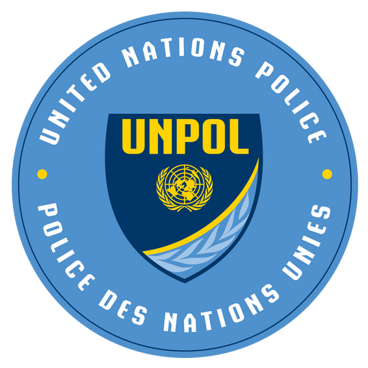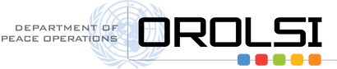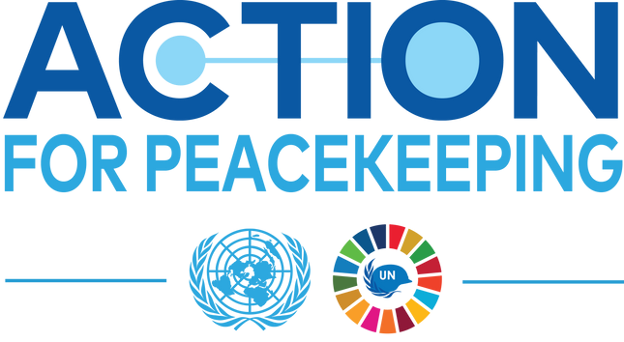

UNCOPS – Background Note for Session 1

Addressing key challenges facing United Nations peacekeeping through Action for Peacekeeping + (A4P+)

Peacekeeping remains one of the most effective tools available to the United Nations in its efforts to promote and maintain international peace and security. At the same time, United Nations peacekeeping faces multiple and persistent challenges. Political solutions in conflict-affected areas are often absent, complex threats are resulting in increased peacekeeper casualties and field missions at times lack the personnel and equipment necessary for success. Compounding matters further are the volatile operating environments that peacekeepers increasingly face, which impede mandate delivery, including with respect to protection of civilians mandates and the safety and security of peacekeepers. In response to these and other challenges, in March 2018 the Secretary-General launched his Action for Peacekeeping (A4P) initiative with a view to renewing the commitment of key stakeholders - Member States, the Security Council, host countries, police- and troop- contributing countries, regional partners, financial contributors, and the United Nations - to the “great enterprise of United Nations peacekeeping.”

In introducing A4P, the Secretary-General called on Member States to join him in developing a set of mutually agreed principles and commitments to enable peacekeeping operations to be fit for the future. Four years since its inception, A4P – and its implementation strategy known as A4P+, which was unveiled in March 2021 – continues to guide the work of the United Nations Police (UNPOL) across seven specific priorities (see below) and two cross-cutting priorities on Women, Peace and Security and innovative, data-driven and technology-enabled peacekeeping. The support and engagement of all stakeholders is essential to realize the full promise of A4P+.

Given the increasingly complex global political context in which UNPOL operate, it is critical for UNPOL to establish and strengthen effective partnerships, identify shared political strategies and support the implementation of political agreements. At the field level, mission-based UNPOL components interact daily with national governments, civil society (including women’s networks) and police and security sector actors.

In parallel with the political strategies that bring on board key stakeholders, UNPOL continue to advance operational and strategic integration. At an operational level, UNPOL contribute to integrated planning and reporting based on joint data and analyses, including the continuous review of Statements of Unit Requirements and the adjustment of contingents’ owned equipment and capability requirements. At the Headquarters level, strategic integration in the policing assistance provided across the United Nations system is ensured through the United Nations Inter-Agency Task Force on Policing (IATF-P), which was established by the Secretary-General’s Executive Committee and is co-chaired by the United Nations Department of Peace Operations and the United Nations Office on Drugs and Crime.

Peacekeeping operations must have the right capabilities in the right place and at the right time, with the right mindsets to deploy more adaptable and capable personnel, including the deployment of more women with the necessary skillsets. The sustainable realization of these aspirations requires doctrinal efforts to ensure interoperability and the alignment of Member State pre-deployment training with the Organization’s in-mission training and national strategies. It is particularly important to ensure that women have equal opportunities to be recruited, trained, supported in their careers and selected for meaningful roles in peacekeeping. For immediate operational demands, the Police Division’s Standing Police Capacity remains an invaluable quick-response asset available to missions and other United Nations entities. Following on from the 2021 Peacekeeping Ministerial in Seoul, UNPOL is working to help current and potential police contributors fulfill the most critical international policing needs.

Accountability to peacekeepers lies at the heart of A4P+, including in cases of crimes committed against them. UNPOL continue to implement the Action Plan for Improving the Security of United Nations Peacekeepers, including efforts to address serious and organized crime, support the implementation of the peacekeeping-intelligence framework and prevent, investigate and prosecute crimes against peacekeepers. The well-being of police personnel also requires gender-responsive working and living conditions and an enabling environment for all police officers. Concurrently, there is a need to ensure the accountability of peacekeepers to Member States and to the people that they serve. UNPOL continually work to improve their evidence-based assessments of performance and to ensure adherence to standards of conduct by reinforcing zero tolerance for sexual exploitation and abuse. This accountability also extends to how UNPOL manage the environmental footprints of field components, in line with their missions’ overall Environmental Risk Management Plans.

The success of United Nations policing depends upon effective strategic communications, which helps to promote inclusivity, manage expectations and preemptively counter disinformation, misinformation and instances of hate speech. It is also used to strengthen UNPOL's engagement with host communities, Member States and partners and as part of improved and targeted recruitment and advocacy efforts for specialized capabilities (including more women and French-speaking officers).

Cooperation with host governments and communities is essential to enable peacekeeping operations to deliver on their mandates. In this regard, UNPOL remain committed to an open dialogue with host-state counterparts, both governments and communities, on the content of UNPOL mandates, strategies and responsibilities.

SEEKING SUPPORT

A4P+ seeks to accelerate progress on the implementation of Declaration of Shared Commitments on UN Peacekeeping (A4P), which aims to ground peacekeeping in realistic expectations, make peacekeeping missions stronger and safer and mobilize greater support for political solutions and for well-equipped, well-trained personnel. We encourage Member States to support these efforts by:

- Advocating for a shared political resolution of the root causes of the security challenges confronting mission settings;
- Providing capacities, equipment and training to counter conventional and unconventional threats, such as improvised explosive devices and unmanned aerial vehicles;
- Nominating more women police officers for service at all levels and functions, as well as more officers with linguistic and other specialized skillsets, such as expertise in forensics, gender, environment or new technologies; and
- Exposing all police personnel to opportunities which enable the development of attitudes and behaviors that advance gender equality in their work.

KEY QUESTIONS

- What reforms, including legislative reforms, can Member States pursue to enhance women police personnel’s access to national and international policing opportunities?
- What additional capabilities and training can Member States provide to help UNPOL better respond to increasingly dangerous environments?
- How can UNPOL and its partners better assist national authorities to prevent crimes against peacekeepers, as well as to investigate and prosecute such crimes when they occur?

